**General PiXL Math App Crib Sheet**

1. Find the PiXL Math App online and select the blue button below:
2. Log in to the system using your password. ##### is the Centre Number.

Example of username John Smith

Username: smithj password: warblington

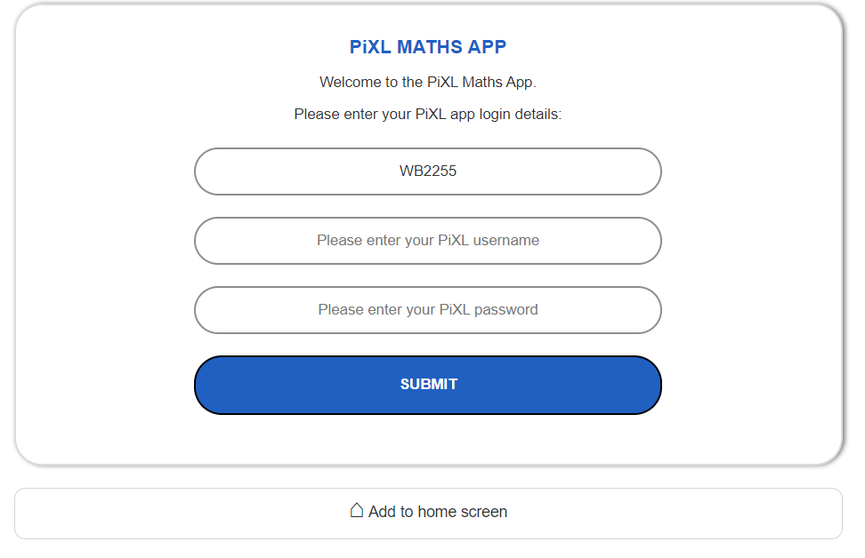

1. Select the ‘Go Green’ section to revise topics that need to be developed:



1. This will select topics personalised to you and what you need to do to improve. Click on the side tabs for help, there are videos and notes to help you.

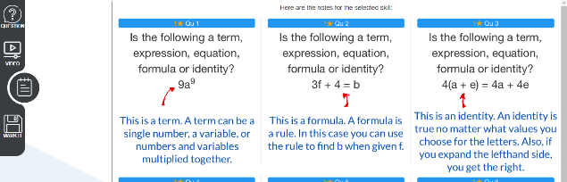

1. Click back on questions to return to something like this

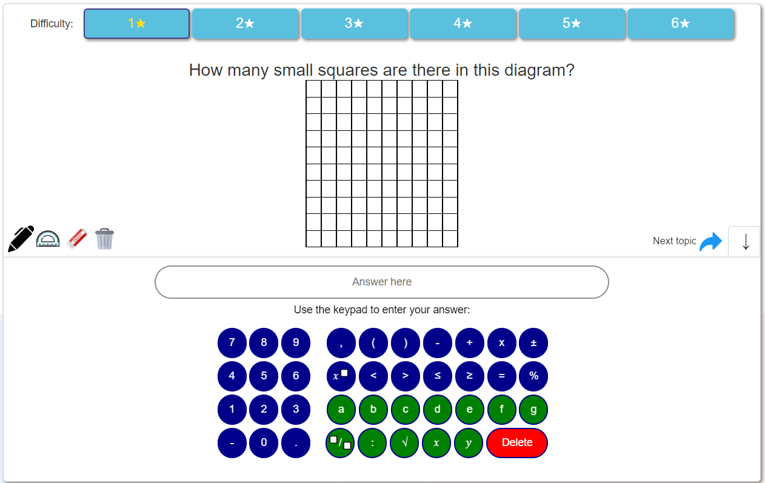

1. Use the pen tool to show any working and then write your answer in the answer box and press return. It will marked and logged in your personal data. If you are not sure why you may have got it wrong, please speak to your teacher, they will have a copy of question on their teacher interface.
2. Use the stars to advance in difficulty through the topic if you are finding the questions too easy.
3. To go to the next topic click the blue arrow in the right hand corner called next topic.
4. To end the test press that button on the top right corner

* You will receive a summary page for information
* Your scores will be updated

Extension: Should you wish to revise something specific

* There is a Test section to generate questions on any topic you choose

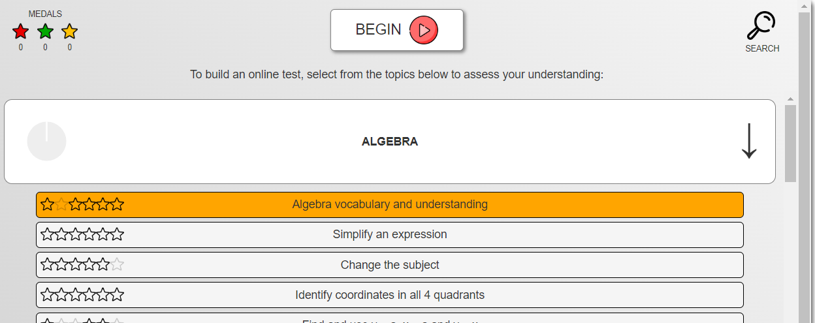

Should you wish to complete some basic numeracy please use the Level Up section below. These are in the same set up as above with videos and notes to help. Once you have completed 13/15 correct you will ‘Level Up’ and higher level questions will be shown.

